Screenshot 1

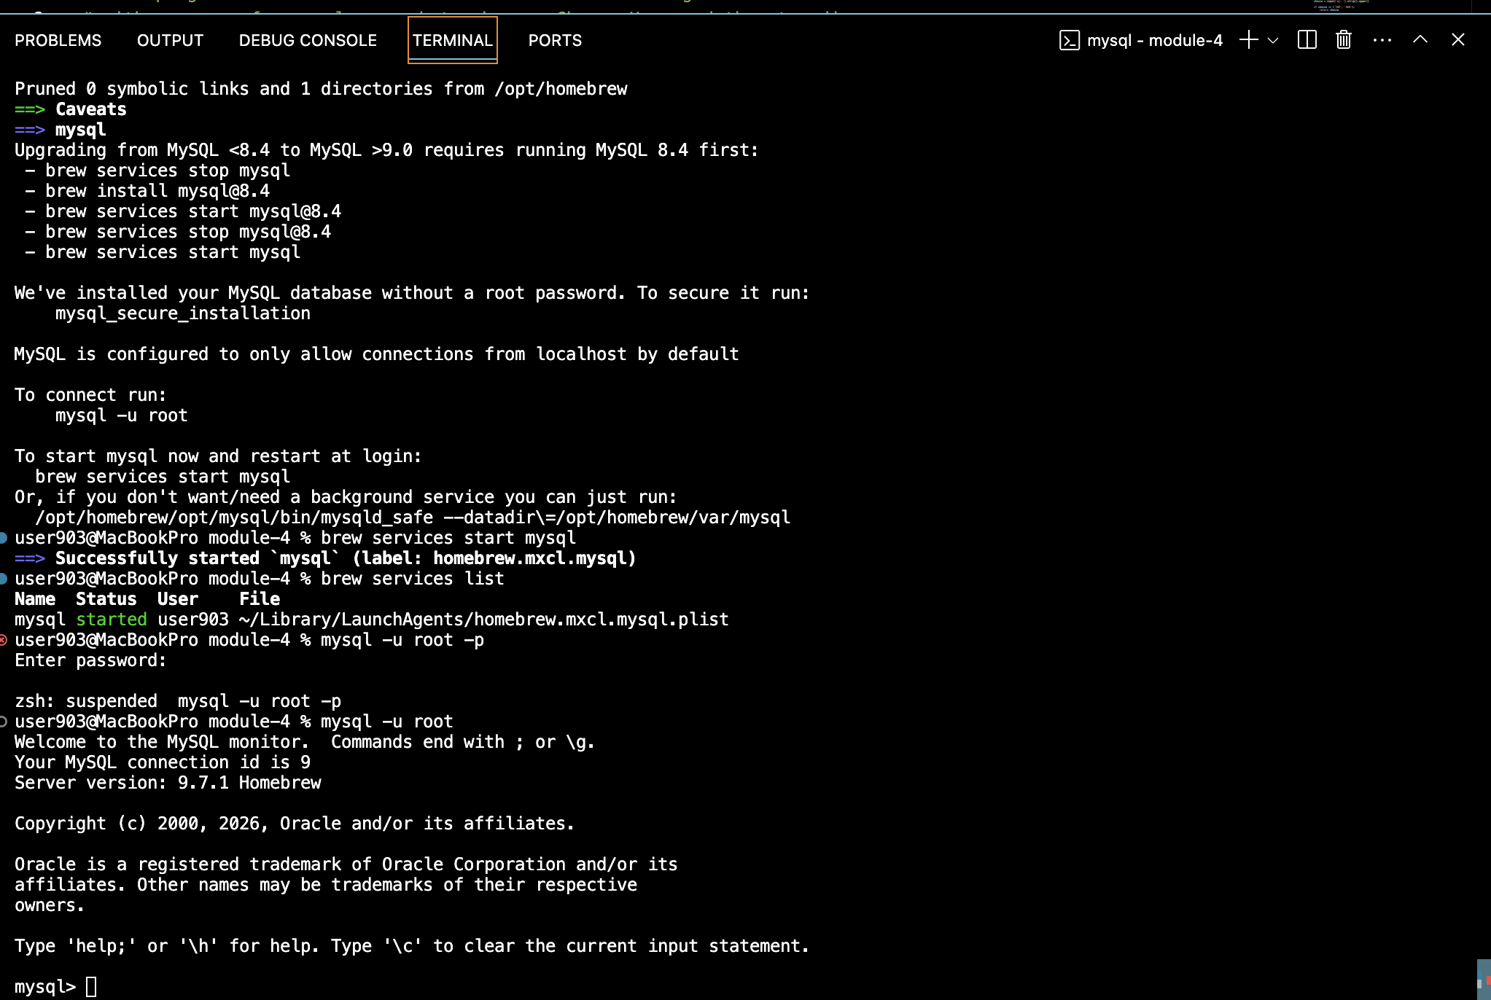

Screenshot 2
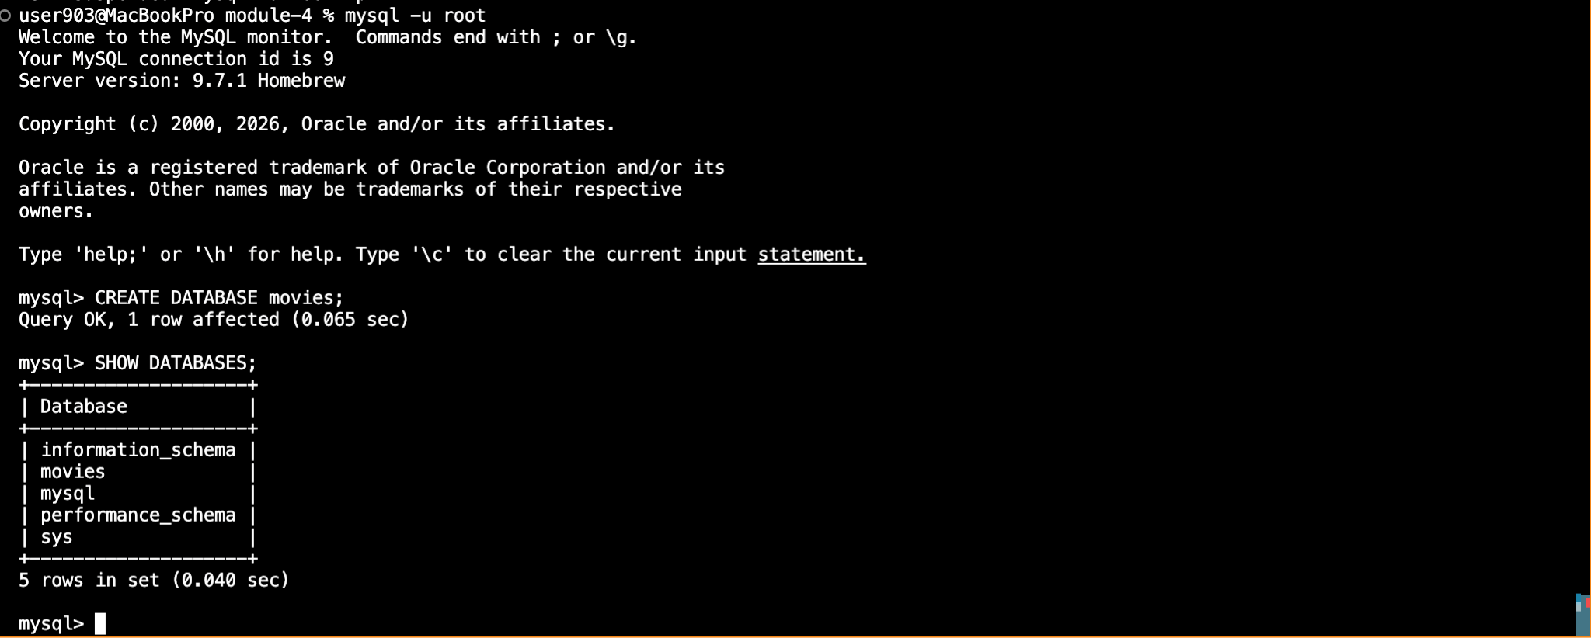

Screenshot 3

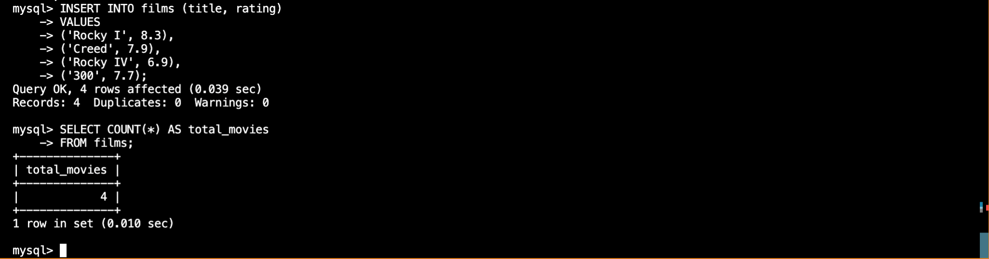

Screenshot 4

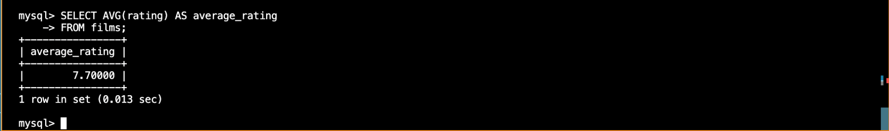

Screenshot 5

